Name:
TEJ 3M Unit 5 Assignment: Logic Gates | Date:
Communication Checklist:  - Clear, neat writing  - All steps shown  - Complete sentences included  - Each question and sub question is worth 0.5 marks
  Application | Communication
  /19 | /9

The purpose of this assignment is to utilize truth tables, simulators or hardware to evaluate circuits. Draw your truth tables and circuits on a separate paper and label each per question. Utilize Multimedia Logic or

Application [ /19]
This part is to be done by hand and on a separate piece of paper. Utilize the simulator if you like for output.
- Draw the Truth Table for the following circuits:
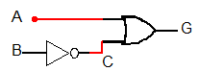
A | B | ~B | A or (~B)
0 | 0 | 1 | 1
0 | 1 | 0 | 1
1 | 0 | 1 | 1
1 | 1 | 0 | 1

- Draw the Truth Table for the following circuits:
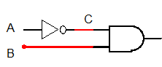
A | B | ~A | ~A and B
0 | 0 | 1 | 0
0 | 1 | 1 | 1
1 | 0 | 0 | 0
1 | 1 | 0 | 0

- Draw the Truth Table for the following circuits:
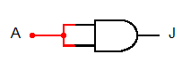
A | A and A
0 | 0
1 | 1

- Draw the Truth Table for the following circuits:
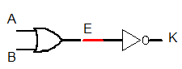
A | B | A or B | !(A or B)
0 | 0 | 0 | 1
0 | 1 | 1 | 0
1 | 0 | 1 | 0
1 | 1 | 1 | 0

- Draw the Truth Table for the following circuits:
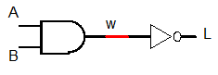
A | B | A and B | !(A and B)
0 | 0 | 0 | 1
0 | 1 | 0 | 1
1 | 0 | 0 | 1
1 | 1 | 1 | 0

- Draw the Truth Table for the following circuits:
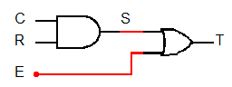
C | R | E | C and R | (C and R) or E
0 | 1 | 1 | 0 | 1
0 | 1 | 0 | 0 | 0
0 | 0 | 1 | 0 | 1
0 | 0 | 0 | 0 | 0
1 | 1 | 1 | 1 | 1
1 | 1 | 0 | 1 | 1
1 | 0 | 1 | 0 | 1
1 | 0 | 0 | 0 | 0

- Draw the Truth Table for the following circuits:
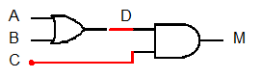
A | B | C | A or B | (A or B) and C
0 | 1 | 1 | 1 | 1
0 | 1 | 0 | 1 | 0
0 | 0 | 1 | 0 | 0
0 | 0 | 0 | 0 | 0
1 | 1 | 1 | 1 | 1
1 | 1 | 0 | 1 | 0
1 | 0 | 1 | 1 | 1
1 | 0 | 0 | 1 | 0

This next part is to be done either on the simulator or with the logic boards. If you are using the logic boards bring me over to your board for marking. If you choose to use the simulator print me the circuit printouts. You can use a combination (For instance use the simulator for the larger function then use the logic board for the simplified version.)

- Make the circuit for the following truth table:
A | B | C | Output
0 | 0 | 0 | 0
0 | 0 | 1 | 1
0 | 1 | 0 | 1
0 | 1 | 1 | 1
1 | 0 | 0 | 0
1 | 0 | 1 | 1
1 | 1 | 0 | 1
1 | 1 | 1 | 1
B or C
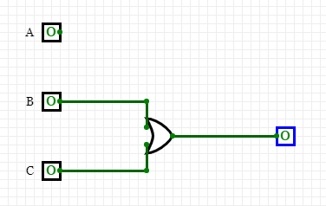

- Make the circuit for the following truth table:
A | B | C | D | Output
0 | 0 | 0 | 0 | 1
0 | 0 | 0 | 1 | 1
0 | 0 | 1 | 0 | 0
0 | 0 | 1 | 1 | 1
0 | 1 | 0 | 0 | 1
0 | 1 | 0 | 1 | 1
0 | 1 | 1 | 0 | 1
0 | 1 | 1 | 1 | 1
1 | 0 | 0 | 0 | 0
1 | 0 | 0 | 1 | 1
1 | 0 | 1 | 0 | 0
1 | 0 | 1 | 1 | 1
1 | 1 | 0 | 0 | 0
1 | 1 | 0 | 1 | 0
1 | 1 | 1 | 0 | 1
1 | 1 | 1 | 1 | 1

AB\CD | 00 | 01 | 10 | 11
00 | 1 | 1 | 0 | 1
01 | 1 | 1 | 1 | 1
10 | 0 | 1 | 0 | 1
11 | 0 | 0 | 1 | 1
D or (D and ~(A and B)) or (~A and ~C) or (C and ~D and B)
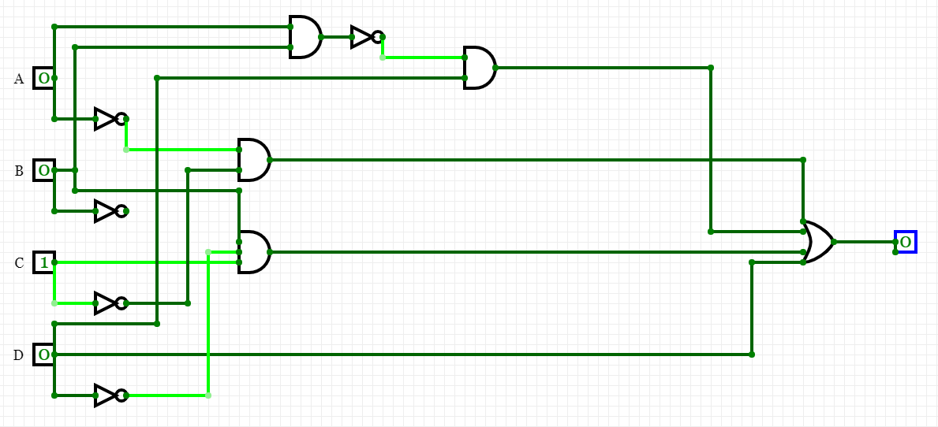

- Make the circuit for the following truth table:
A | B | C | D | Output
0 | 0 | 0 | 0 | 1
0 | 0 | 0 | 1 | 1
0 | 0 | 1 | 0 | 0
0 | 0 | 1 | 1 | 0
0 | 1 | 0 | 0 | 1
0 | 1 | 0 | 1 | 1
0 | 1 | 1 | 0 | 1
0 | 1 | 1 | 1 | 1
1 | 0 | 0 | 0 | 0
1 | 0 | 0 | 1 | 1
1 | 0 | 1 | 0 | 0
1 | 0 | 1 | 1 | 1
1 | 1 | 0 | 0 | 1
1 | 1 | 0 | 1 | 1
1 | 1 | 1 | 0 | 1
1 | 1 | 1 | 1 | 1

AB/CD | 00 | 01 | 10 | 11
00 | 1 | 1 | 0 | 0
01 | 1 | 1 | 1 | 1
10 | 0 | 1 | 0 | 1
11 | 0 | 1 | 1 | 1

(~A and ~C) or D or B or (B and (C or D))

- Use a K-map to simplify the truth table in question 8.

A | B | C | Output
0 | 0 | 0 | 0
0 | 0 | 1 | 1
0 | 1 | 0 | 1
0 | 1 | 1 | 1
1 | 0 | 0 | 0
1 | 0 | 1 | 1
1 | 1 | 0 | 1
1 | 1 | 1 | 1

A/BC | 00 | 01 | 10 | 11
0 | 0 | 1 | 1 | 1
1 | 0 | 1 | 1 | 1

A doesn’t change anything

B | C | Output
0 | 0 | 0
0 | 1 | 1
1 | 0 | 1
1 | 1 | 1
0 | 0 | 0
0 | 1 | 1
1 | 0 | 1
1 | 1 | 1

- Write the simplified equation for question 11.

A/BC | 00 | 01 | 10 | 11
0 | 0 | 1 | 1 | 1
1 | 0 | 1 | 1 | 1

B or C

- Print out the circuit for the shortened equation in question 11, or show me the logic circuit.
- Use a K-map to simplify the truth table in question 9.
AB\CD | 00 | 01 | 10 | 11
00 | 1 | 1 | 0 | 1
01 | 1 | 1 | 1 | 1
10 | 0 | 1 | 0 | 1
11 | 0 | 0 | 1 | 1

- Write the simplified equation for question
D or (D and ~(A and B)) or (~A and ~C) or (C and ~D and B)

- Print out the circuit for the shortened equation in question 14, or show me the logic circuit.
- Use a K-map to simplify the truth table in question 10.
AB/CD | 00 | 01 | 10 | 11
00 | 1 | 1 | 0 | 0
01 | 1 | 1 | 1 | 1
10 | 0 | 1 | 0 | 1
11 | 0 | 1 | 1 | 1

- Write the simplified equation for question
(~A and ~C) or D or B or (B and (C or D))

- Print out the circuit for the shortened equation in question 17, or show me the logic circuit.

